End of Year Events at Grandview-Hopkins May 24th instead
Monday May 20th - Wonderland Park Field trip for all grades. Wear your Grandview-Hopkins Soaring Eagle t-shirt.
See separate note sent home for more details.

Tuesday May 21st – You are invited to the Grandview-Hopkins Graduation and Awards Ceremony at 7 p.m. Students are expected to arrive at 6:30 p.m. Awards will be given for Kindergarten through 6th grade. Graduation will be for Kindergarten and 6th grade. Students should dress up for the occasion. PTA will provide cake and punch at the awards ceremony.

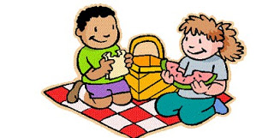
Thursday May 23rd – Last Day of School. Grandview-Hopkins Annual Community Barbeque will be at noon. Weather permitting the traditional water gun fight will follow the barbeque. The school will provide water guns for the water gun fight after the Barbeque. Do not bring your own water guns. Do bring a towel to dry off. School will dismiss at 1:30 and the Pampa bus will arrive in Pampa at 2:00 pm. You are invited to bring your favorite covered dish or dessert and join the meal. Come and Enjoy the Feast!

