End of Year Events - There are some Changes!
Tuesday May 17th - Field trip for Kindergarten – 2nd grade. Wear your Camo Grandview-Hopkins t-shirt. Due to weather we are no longer going to the Zoo. Instead the students will be going to Jump ‘n Jive. A sack lunch will not be required. The school will provide pizza and drinks for the students. Socks are required.

Wednesday May 18th – Yearbooks will be sent home. Hope you enjoy

Thursday May 19th-20th – Sixth grade trip to Dallas. Pack your Camo Grandview-Hopkins t-shirt. A separate note has been sent with 6th graders.

Next Tuesday May 24th –All school field trip to Wonderland. Wear your Camo Grandview-Hopkins t-shirt. All students must ride the bus to Wonderland Park and to Mr. Gattis Pizza. Parents may take students home from Mr. Gattis. See back side for details.

Next Thursday May 26th 7 p.m. – You are invited to the Grandview-Hopkins
Graduation and Awards Ceremony. Awards will be given for Kindergarten through 6th grade. Graduation will be for Kindergarten and 6th grade. Students should dress up for the occasion. PTA will provide cake and punch at the awards ceremony.

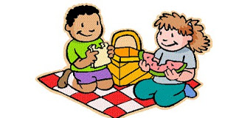
Next Friday May 27th – Last Day of School. Grandview-Hopkins Annual Community Barbeque will be Friday at noon. Weather permitting the traditional water gun fight will follow the barbeque. The school will provide water guns for the water gun fight after the Barbeque. Do not bring your own water guns. School will dismiss at 1:30 and the Pampa bus will arrive in Pampa at 2:00 pm. You are invited to bring your favorite covered dish or dessert and join the meal. Come and Enjoy the Feast!

